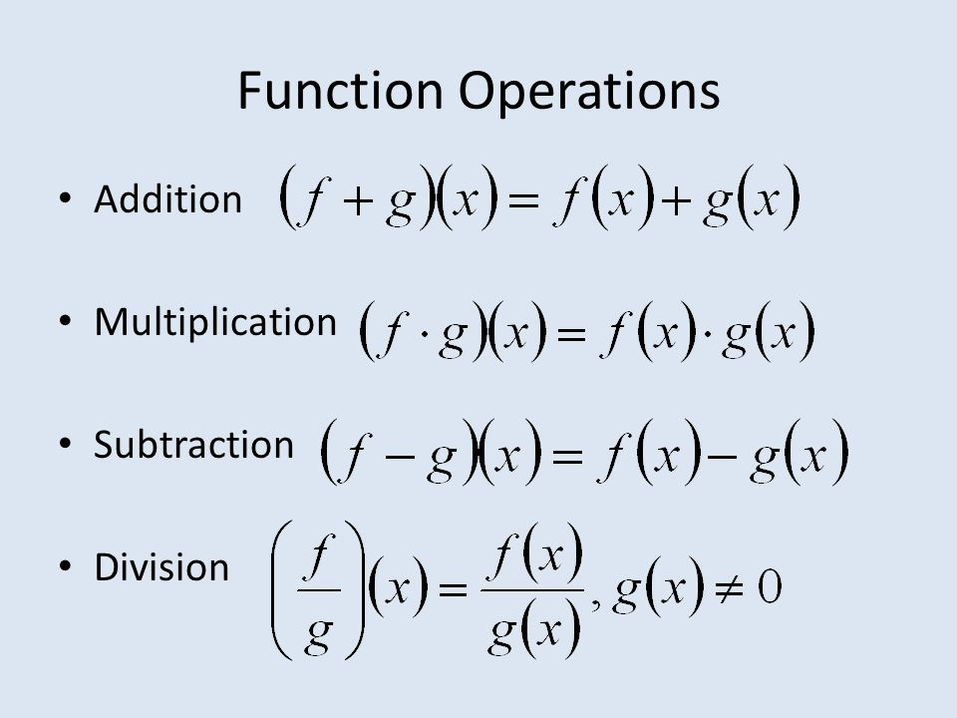
Unit 1 - Lesson #2: Function Operations
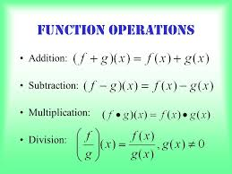

Learning Targets:
SWUT:
That functions can be added, subtracted multiplied and divided the same way that they are performed on real numbers.

A composition of a function, defined as$\left(g∘f\right)\left(x\right)=(g(f\left(x\right))$, is when one function is operated on a second function. The output (range) from one function is the input (domain) of the second function.

When finding the composition of a function, the inside function is operated on FIRST.

Functions can be written to represent real life situations and be used to make decisions.

In a fractions, domains must be restricted so a denominator will not be zero and in a radical the radicand in an even root is not negative.

Domains must be restricted so a denominator is not undefined, there are no negatives under the radical, or any combination of the two.

REVIEW ALGEBRA 1: DO IT!!! (a thru f)
Exercise 1: If $f\left(x\right)=4x+7$, $g\left(x\right)=\sqrt{x}+2$, and $h\left(x\right)=x^{2}-3x$, evaluate each of the following:

a) $f\left(-2\right)$ b) $\frac{f(-1)}{g(1)}$ c) $g\left(25\right)-h(-2)$

d) $f\left(x\right)+h(x)$ e) $f\left(x\right)∙f(x)$ f) $f(x+1)$

Composition of Functions
Remember this in Geometry?! Find the coordinates of r_{y-axis} o r_{y=x} (A) if A is
the point (6,1)

What did the “$o"$ symbol mean?

We use the same symbol, with the same meaning in Algebra II….. WITH FUNCTIONS!

$(f o g)(x)$ $f(g(x))$

Ex 1: If $f\left(x\right)=2x-4$ and $g\left(x\right)=|x-3|$, find the value of
a) $(f o g)(-2)$ b) $g(f\left(10\right))$

Ex 2: If $f\left(x\right)=x^{3}+3x^{2}$ and $g\left(x\right)=-x^{2}+1$, what is the value of
a) $(f o g)(-3)$ b) $g(f\left(-4\right))$

Applications

- You have a coupon good for $5.00 off the price of any large pizza. You also get a 10% discount if you show your student ID. If a pizza is regularly priced at $15.00, is it better to apply the coupon or the discount first? Justify your answer.

- Physics students are studying the effect of temperature, T, on the speed of sound, S. They find that the speed of sound in meters per second is a function of the temperature in degrees Kelvin, K, by $S\left(K\right)=\sqrt{410K}$. The degrees Kelvin is a function of the temperature in Celsius given by $K\left(C\right)=C+273.15$. Find the speed of sound when the temperature is 30 degrees Celsius. Round to the nearest tenth.

Average Rate of Change (SLOPE! SLOPE! SLOPE!)
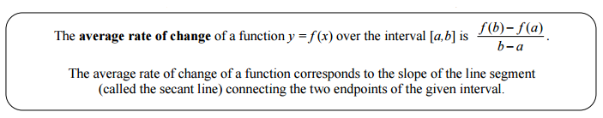
Example 1:
- Graph $f(x)={(x-2)}^{2}+3$

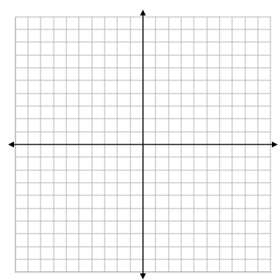
- Plot the points $(0,7)$ and $(3,4)$ on
the graph and draw a line segment
connecting them.

- Find the slope of the line segment.

- Using the “average rate of change”
formula above, find the average rate
of change $f(x)$ on the interval $x = 0$
to $x = 3$

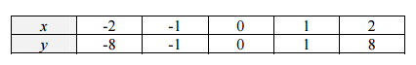
Example 2: Given

- Determine the average rate of change of $y$ over the interval from $x = -1$ to $x = 1$

- Determine the average rate of change of $y$ over the interval $-2≤x≤1$.

Example 3: Determine which of the following functions has the greater average rate of change over the interval $[2,5]$. Explain your reasoning.

x | g(x)
0 | 1
1 | 6
2 | 11
3 | 16
4 | 21
5 | 26
$$f(x) = 4x + 3$$

Homework: 1 – 2
And the following Average Rate of Change questions:
- Calculate the average rate of change in library income between 2010 and 2013.
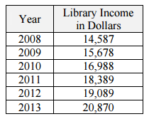

- Given $f\left(x\right)=2x^{2}$. Find a value b such that the average rate of change of $f(x)$ from, $x = 1$ to $x = b,$ is equal to 12.

***ALGEBRA 2 REGENTS REVIEW***
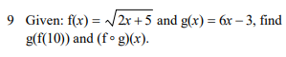
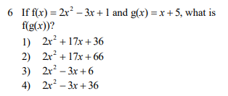

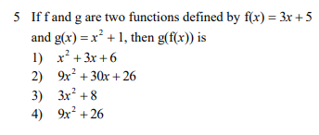

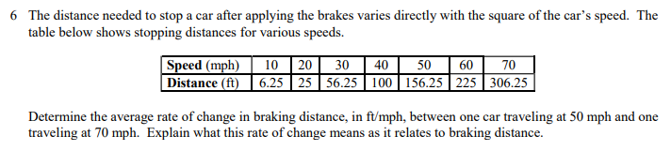

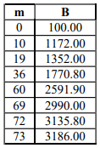
1. Joelle has a credit card that has a 19.2% annual interest rate compounded monthly. She owes a total balance of B dollars after m months. Assuming she makes no payments on her account, the table below illustrates the balance she owes after m months.
Over which interval of time is her average rate of change for the balance on her credit card account the greatest?
1) month 10 to month 60 3) month 36 to month 72 2) month 19 to month 69 4) month 60 to month 73

